Spotlight 6. Module 6. Check.
- Form compound nouns.

- under
- country
- hair
- drug
- jig
- rain
- spot
- side
- bow
- dresser
- light
- ground
- store
- saw

- Circle the odd word out.
- marbles-scrabble-chess-permanent
- be good at-go on trips-be keen on- be mad about
- chess board-dart set-pawn-solve a crime
- scissors-glue-weapon-paper

- Complete the gaps with the words below.
• fair • have • ladders • mad • grows • dull

- Kathy likes to ___________ fun.
- They are _______________ about music.
- That restaurant looks very________________. I don`t want to go there.
- It`s not ____________. I always tidy our room but you don`t.
- Our favourite board game is Snakes and __________________.
- My granny ____________ apples in her garden.

- Choose the correct verb form
- Who……………………..( make) that terrible noise?
- Bobby……………………..(read) a magazine every evening.
- You can’t see Elsa now, she ……………………………(have )a bath.
- I usually…………………….( drink ) tea at 5 o`clock.
- She …………………………….(not study) Spanish.
- Gregory and Claire ………………………………..(have ) their lunch in the hotel room.
- Where you …………………………..(go), Patrick?
- My Mum ____________ in a school (teach)

- Put the words in the right order

- gets / up / very / Paul / usually / early
- the / are / the / playing / garden / in / children
- father / in / works / a / my / bank
- every / ride / school / morning / bike / to / I / my
- like / Sundays / they / visit / to / us / on

- Write the words.
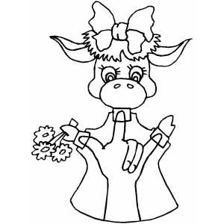
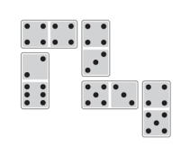
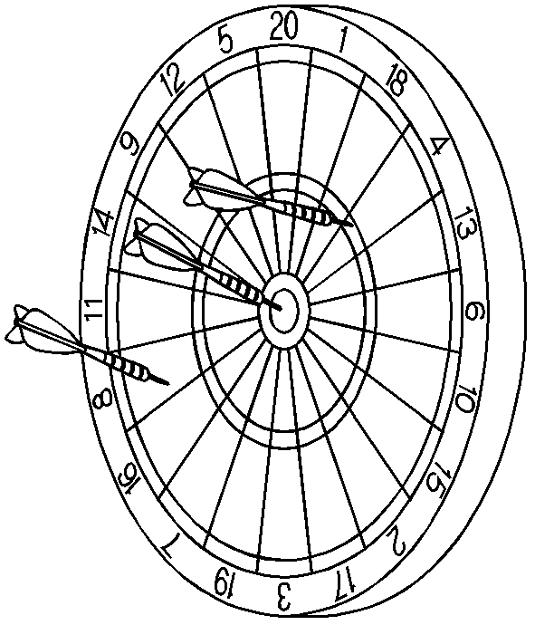
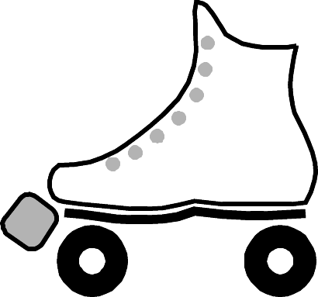
- 32. 33. 34. 35.

- Guess the word.

- You just take a piece of cloth, attach a wooden or rubber head and put it over tour hand. You use your fingers to move its head and arms.
- The aim of this game is to make as much money as possible. In order to do that players buy, sell and rent property. One by one, the players run out of money and the last player left is the winner. It`s the best selling board game in the word.

- Match.
- About good and evil | - Нужны фишки
- You need some counter | - Кто первый достигнет последней клетки, тот победил!
- Whoever gets to the last square first wins! | - О добре и зле.
Total:
24-29-“3”
30-35-“4”
36-40-“5”

