Spotlight 6. Module 9. Check.
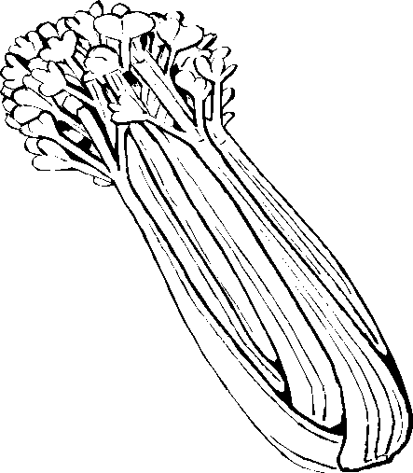
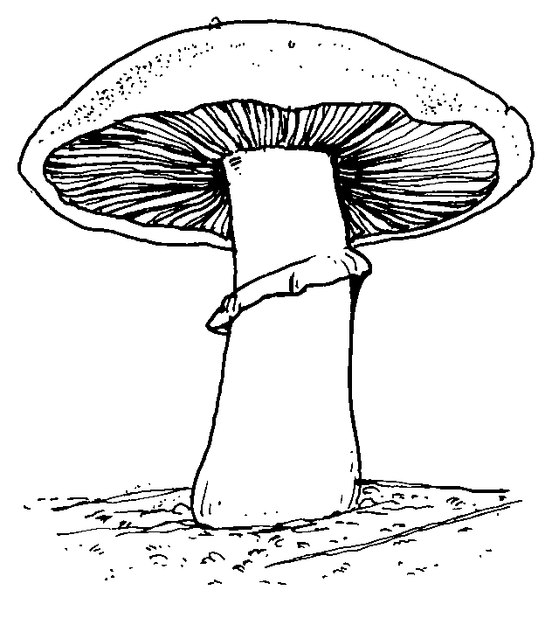
- Write the words.
- _ _ _ _ s 2. _ _ _ _ _ _ 3. _ _ _ _ _ _ _ _
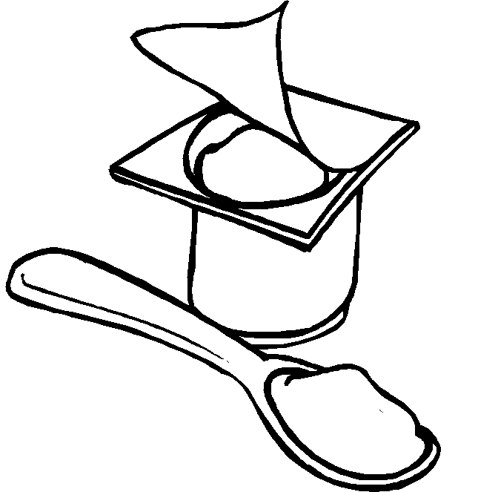
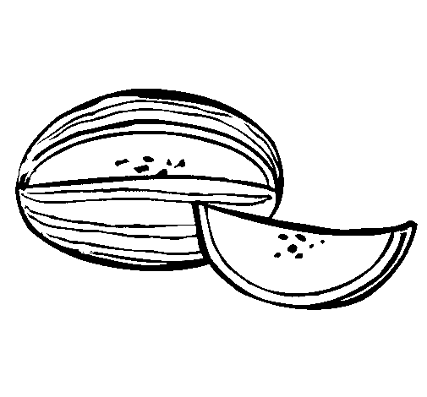
- _ _ _ _ _ 5. _ _ _ _ _ _ 6. _ _ _ _ _ _ _

- Circle out the odd word.
- milk juice water oil
- onion banana garlic tomato
- fish lamb beef pork
- apple orange carrot grape
- stir waiter mix peel

- Match the words in two columns to get expressions with containers and quantities.

- A bottle of | - cereal
- A carton of | - olive oil
- A box of | - potato
- A packet of | - milk
- A piece of | - chocolate
- A kilo of | - crisps
- A jar of | - bread
- A bag of | - jam
- A loaf of | - cheese
- A bar of | - rice

- Choose the correct word.

- Please have some/ few/ much of these chocolates. I know you like them.
- Have you got much/ many/some coffee?
- There isn't some /any /many water in the bottle.
- Have we got some/ any/ a lot of milk?
- There was a few/ a little/ much food in the fridge. It was nearly empty.
- Is there many/ much/ a little cake?
- There isn’t a little/ much/ many chicken.
- There’re a lot of/ few/ a little carrots in the fridge. We need to buy some.
- There aren’t much/ many/ some tomatoes.

- Put the verbs into the PRESENT SIMPLE, PRESENT CONTINUOUS or PAST SIMPLE.
- On Mondays, I _______________ in the swimming-pool with my friends (swim)
- Stop singing! I ______________________ my lessons (do)
- I _________ Sue at the pub yesterday. (meet)
- The children didn`t____________ to school yesterday. (come)
- We ___________ at home last night. (be)
- He sometimes _________ to the cinema (go)

- Choose the correct answer.

- The English have … for breakfast.
A – cereal or toast with tea
B- spaghetti and coffee

- Sunday roast is…
A – roast chicken with potatoes and gravy
B – roast beef with potatoes, vegetables and gravy
- The English have… for dessert
A – home made puddings, apple pie and trifle
B – fruit salad and biscuits

- A packed lunch is…
A – a sandwich, a packet of crisps, a piece of fruit and drink
B – salad, shepherd’s pie, juice
Total:
24-29-“3”
30-35-“4”
36-40-“5”

Answers.

- beans
- celery
- mushroom
- melon
- muffin
- yoghurt
- oil
- banana
- fish
- carrot
- waiter
- b
- d
- a
- f
- i
- c
- h
- j
- g

- e
- some
- much
- any
- any
- a little
- much
- much
- few
- many
- swim
- am doing
- met
- come
- were
- goes
- A
- B
- A
- A
Total:
24-29-“3”
30-35-“4”
36-40-“5”

