Spotlight 6. Unit 8. Check.
- Fill in the right word.
- When we go camping I always help my dad to put the _ _ _ _ up.
- On holidays we stay in a five-star _ _ _ _ _ .
- She likes to walk _ _ _ _ _ _ _ _ in the park, without her shoes.
- There is a new painting at the art _ _ _ _ _ _.
- Look at the _ _ _ _ _ _ _ _ _ to know when this train starts tomorrow.

- Match.

- kitchen
- types of
- block of
- smoked
- ticket
- look
- out of

- flats
- appliances
- after
- salmon
- dwelling
- counter
- order

- Complete.

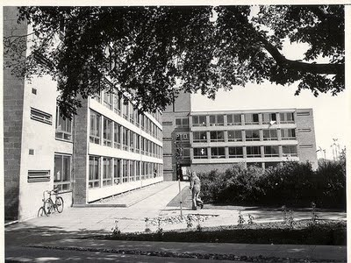

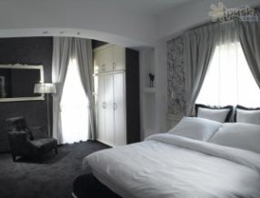
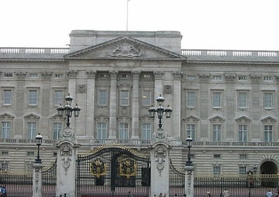
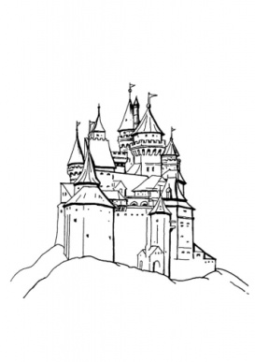
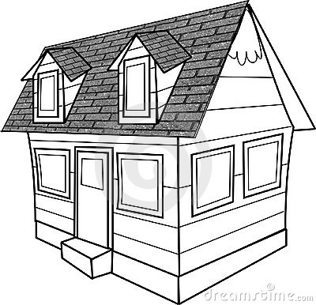
15. university _ _ _ l _ and 16. r _ _ _ _ _ _ c _
14. p_ _ _ _ _e
13. _ o _ _ _ _ e
18. c_ s _ _ _
17. _ _ _ _ l
Types of DWELLINGS
- Write the correct comparative.
19. February is __________month in the year (short)
20. She is one of ______________ tennis players in the world. (good)
21. My father is ________ my brother (strong)
22. A sofa is ___________ a chair (comfortable)
23. My grandfather is _________ person in my family (old)
- A car is __________ a bike (expensive)
- Sharks are __________ animals in the sea.(dangerous)
E. Choose the correct word.
- I must / have to visit my friend. It is her birthday.
- I can / mustn’t swim very fast.
- My grandmother need to/needs to/ have to ……..take this medicine in the morning.

- Choose the right answer.

- 1...................to go to school on holidays?
- must you have
- can you have
- do you have
- Sally is ill. She ................stay in bed.
- can
- has to
- mustn’t
- Mum.............I stay out late tonight?
- Have
- can
- has

- Read about Ostankino Tower and make an outline of the text:
The total height of the Ostankino Tower (designed by Nikolai Nikitin) is 540 meters. Construction began in 1963 and was completed in 1967. It is the highest freestanding building in Europe and Asia. At one time, the Ostankino TV Tower was the highest construction in the world. This grandiose construction has 45 levels, tens of ring decks and balconies It has also got a restaurant called “The seventh sky” with a glass revolving floor. The restaurant opens a fantastic view over Moscow.
- When:
- Who:
- Height:
- What it has:

- Put the verb in brackets in the correct tense:
- It’s eleven o’clock now. Terry _______________ (get up).
- Excuse me, _____________________ (you/speak) English?
- We __________ (go) to the ZOO with our teachers last Saturday.
- I _________________(be) at school yesterday.
- Mr. Moore ___________ (travel) to London every day.
Total:
24-29-“3”
30-35-“4”
36-40-“5”

