**Spotlight 6. Module 10. Check.**

1. **What are they wearing? Match.**

**D**

**H**



**A**

**B**

**C**

**E**

**G**

**F**

1. Laura is wearing jeans and a pink shirt, also is wearing a brown belt.
2. Tammy is wearing boots, a green blouse and gray trousers.
3. Fred is wearing black shoes, a denim jacket, green pants and beige shirt.
4. Paul is wearing brown boots, blue jeand and a green T’shirt.
5. Lucy is wearing brown high heels, tights, a grey jacket and a light blue skirt.
6. Mark is wearing brown shoes, black belt, blue jeans and a red t’shirt
7. Kate is wearing black boots, two blouses, one green and the other one is blue, and grey trousers.
8. Susan`s wearing blue leggins, blue boots, green blouse, fucsia ponytail and same colour of skirt.
9. **What`s the weather like? Write the adjective. Finish the sentence *It`s … .***

**11**.

**10**.

**9**.

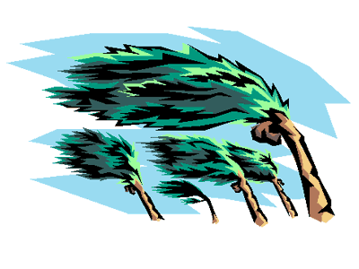



**14**.

**17**.

**16**.

**15**.

**13**.

**12**.

1. **Choose the best word for the thing described. Match. One word is EXTRA.( DON`T use it)**

|  |  |
| --- | --- |
| 1. A room for one person 2. A room for two people 3. All meals included 4. A room with two beds 5. Breakfast and evening meal included 6. Give extra money to the waiter 7. Reserve a room 8. Spend time at a hotel   have*,* win*,* rain*,* be late*,* kiss | 1. full board 2. single 3. half board 4. twin 5. tip 6. book 7. double 8. check in 9. stay |

1. **Fill in with the words from the box:**
2. Take an umbrella. It’s going to _____________.
3. Look at the time! You’re going to ____________ for the meeting.
4. Anna’s running very fast. She’s going to ___________ the race.
5. They’re going to ________ a baby. It’s due next month.
6. There’s my sister and her boyfriend! They’re going to _________.
7. **Complete the sentences with “will”, going to, Present Continuous.**
8. Laura _________________ (go) to London next week.
9. _________________ (have) a party next Saturday.
10. I hope it ___________ (rain) during the holidays.
11. We ___________ (organise) a trip next weekend.
12. It’s very hot. I ________________ (open) the windows.
13. She can’t go with you this afternoon. She ___________ (go) to the dentist.
14. Why are you wearing trainers? Because I ___________ (play) tennis.
15. We__________ (meet) our friends tonight.
16. The teacher is really angry with Tom. She ____________ (call) his parents.
17. What are your plans for next summer? I ________ (visit) my grandparents in Bristol.

**Total:**

24-29-“**3**”

30-35-“**4**”

36-40-“**5**”

**Answers.**

1. C
2. B
3. H
4. A
5. F
6. D
7. G
8. E
9. It`s rainy
10. It`s sunny
11. It`s stormy
12. It`s foggy
13. It`s hot
14. It`s icy
15. It`s cloudy
16. It`s windy
17. It`s snowy
18. B
19. G
20. A
21. D
22. C
23. E
24. F
25. I
26. rain
27. be late
28. win
29. have
30. Kiss
31. is going
32. Are you having/Are you going to have
33. will rain
34. are going to organise
35. will open
36. is going
37. am going to play
38. are meeting
39. Is going to call
40. Am going to