**Spotlight 6. Module 2. Check.**

1. 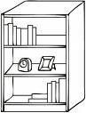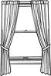**Write the names of the furniture.**

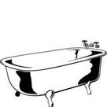**[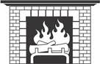](http://www.google.pt/imgres?imgurl=http://www.fotosearch.com/bthumb/SUE/SUE104/BWBW1161.jpg&imgrefurl=http://www.fotosearch.com/clip-art/fireplace.html&usg=__tX2V1t7gyeLCCKNOWJW1buELXFc=&h=110&w=170&sz=7&hl=pt-pt&start=36&zoom=1&tbnid=bj_mjgY2PVCy1M:&tbnh=88&tbnw=136&prev=/images?q=clipart+fire+place&um=1&hl=pt-pt&sa=N&rlz=1T4ADFA_pt-PTPT388PT402&biw=1259&bih=481&tbs=isch:1&um=1&itbs=1&iact=hc&vpx=834&vpy=185&dur=344&hovh=88&hovw=136&tx=80&ty=72&ei=bpPhTI2PBYiH4QalutWFBQ&oei=XZPhTOfhD8KA4QbM-s2EBQ&esq=4&page=4&ndsp=12&ved=1t:429,r:10,s:36)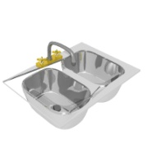1.**  **2. 3.  4. 5. 6. 7.**

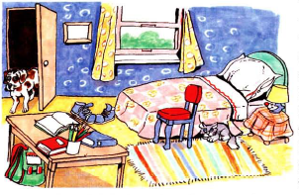 **B.**  **Look at the picture and complete the sentencesusing *IN, ON, UNDER, BEHIND, NEXT TO, BETWEEN, OPPOSITE, NEAR***

**8**. The cat is......................the chair and the small table.

**9**. The bed is.......................the wall.

1. The chair is.......................the bed
2. The book is.................. the table.
3. The carpet is......................the chair.
4. The dog is.....................the door.
5. The small table.................... the room.
6. The big table is.................... the chair.
7. **What time is it?**
8. 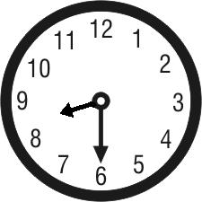 **17.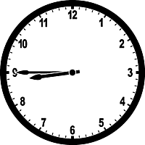 18.** 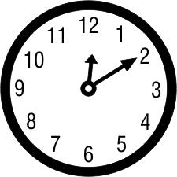  **19.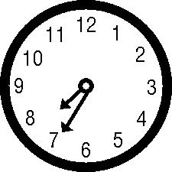 20.** 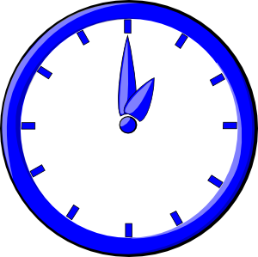
9. **Fill in: AT, IN, ON.**
10. What do you do ________ Saturdays?
11. The school starts ________ 8 o’clock.
12. I sometimes work ________ Tuesday morning.
13. I was born _____________ 1993.
14. Tom’s mother works _____________ night.
15. I do my homework ______________ the afternoon.
16. It’s very hot ___________ summer.
17. **Choose the correct word.**
18. There’s ***a/any*** coffee table next to the sofa.
19. There are **some/any** paintings on the wall.
20. There isn`t **a**/**any** cat on the sofa.
21. There aren`t **any/some** newspapers under the table.
22. **Match.**
23. Watch
24. Calm
25. Post
26. Heel and
27. What`s
28. toe
29. out!
30. office
31. up
32. down!
33. **Write the numbers.**

**Total:**

24-29-“**3**”

30-35-“**4**”

36-40-“**5**”

1. 21nd
2. 41st
3. 12th
4. 30th

**Answers.**

1. shelf
2. sink
3. wardrobe
4. fireplace
5. bathtub
6. curtains
7. bookcase
8. between
9. near/next to
10. near/next to
11. on
12. under
13. behind
14. in
15. opposite
16. It`s half past eight
17. It`s quarter to nine
18. It`s ten past twelve
19. It`s twenty five to eight
20. It`s one o`clock
21. on
22. at
23. on
24. in
25. at
26. in
27. in
28. a
29. some
30. a
31. any
32. b
33. e
34. c
35. a
36. d
37. twenty second
38. forty first
39. twelfth
40. thirtieth